Software Requirement Specification (SRS)

# Project Title: Sun-Shine Farm Inc.

## Requirements:

We need to build a software for Sun-Shine Farm. The application will have following features:

## There will be two types of user like admin and customers.

## There will be employees like manager, drivers, Guards and farmers.

## There will be login for admin and customers.

## Customers can register through email.

## Admin can see, add & edit every crops, employees etc.

## Customers can only see tables like crop list, equipment list etc.

## Customers can edit their profile from user-list.

## Customers can add their images.

* + Manager is responsible for keeping record of expenses and sales of the farm.
  + Manager is responsible for salary expense, utility expense, rent expense and executive is responsible miscellaneous expenses.
  + Driver is responsible for car-fuel expense and taking crops from farm to Super-Market with manager.
  + Executive is responsible for selling crops to Super-Market.
  + Manager is responsible for purchasing equipment.
  + Farmers are responsible for purchasing insecticides and pesticides.
  + Farmers are responsible for growing crops.
  + Customers purchase crops from Super-Market.
  + Customers can also purchase crops from farm.

## Analysis and Design:

### Brainstorming Diagram:

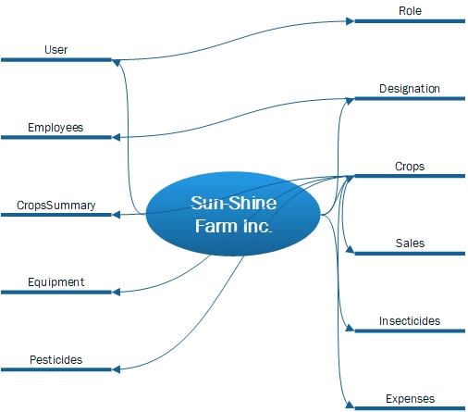

### Use Case Diagram:

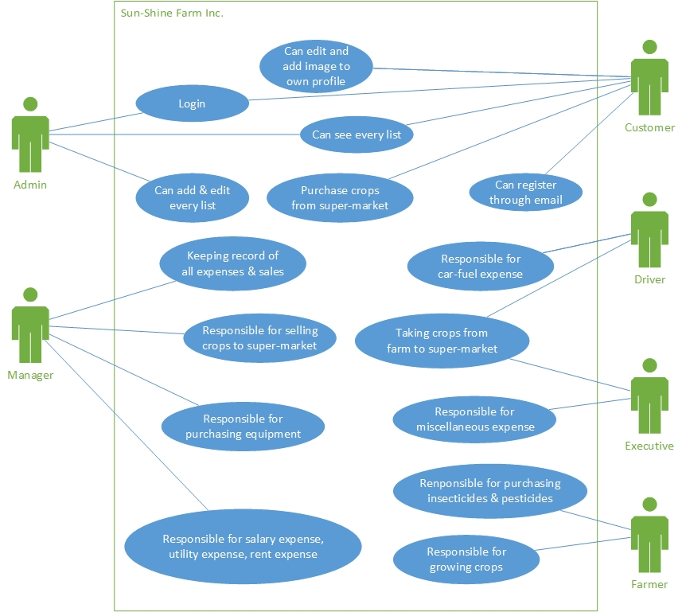

### Class Diagram: